DATABASE MANAGEMENT SYSTEM LAB FILE

NAME- DAKSH AHUJA

ROLL NO- 014

SECTION-IB

**Exercise No.-1**

**TITLE: CREATION OF TABLES**

**1)Create a table called student I'd with the following structure.**

|  |  |
| --- | --- |
| NAME | TYPE |
| Empno | Number |
| Ename | Varchar2(20) |
| Job | Varchar2(20) |
| Mgr | Number |
| Sal | Number |

Queries

1. Add a column commission with the domain to the employee table.
2. Insert any five records into the table.
3. Update the column details of job.
4. Rename the column of employee table using alter command.
5. Delete the employee whose empno is 05.

**Objective: Implement the basic knowledge of SQL queries and relational algebra.**

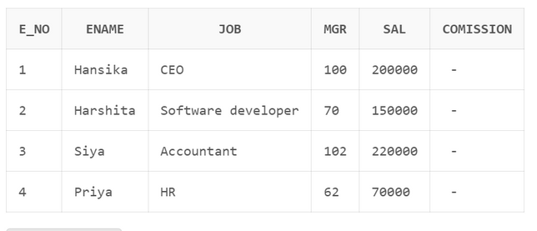

**Pre-requisites: Basic understanding of SQL**

**SOLUTION:**

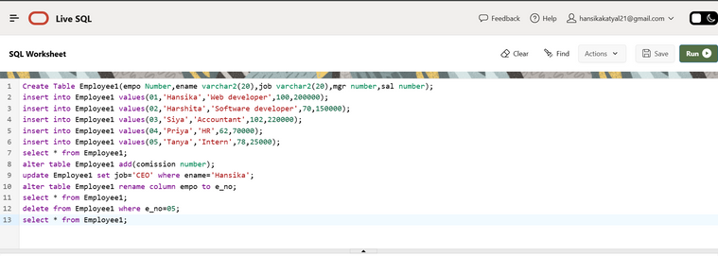

**Exercise No.-2**

**TITLE: CREATION OF TABLE**

2) Create department table with the following structure.

|  |  |
| --- | --- |
| **Name** | **Type** |
| Deptno | Number |
| Deptname | Varchar2(20) |
| Location | Varchar2(20) |

Objective: Implement the basic knowledge of SQL queries and relational algebra.

Pre-requisites: Basic understanding of SQL

**SOLUTION:**

a. Add column designation to the department table.

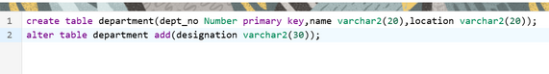

b. Insert values into the table.

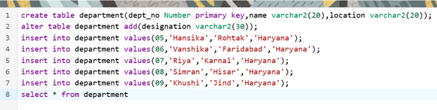

Output:

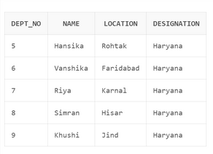

c. List the records of emp table grouped by deptno.

ec987e9539d0558686499155255808dc.png

Output :

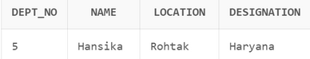

d. Update the record where deptno is 104.

c16650f4ce6c86c57be1fac2aeeea48d.png

Output:

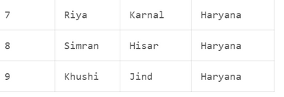

e. Delete any column data from the table.

f74ac6f8b82ce09803f9f046417448e2.png

Output:



Exercise No.-3

**TITLE: CREATION OF TABLES**

**3)** Create table called customer table.

|  |  |
| --- | --- |
| **Name** | **Type** |
| Cust_name | varchar2(20) |
| cust_street | varchar2(20) |
| cust _city | varchar2(20) |

**Objective: Implement the basic knowledge of SQL queries and relational algebra.**

**Pre-requisites: Basic understanding of SQL**

**SOLUTION:**

0ea69a6f261548c23804c1b34749cb1c.png

Output:

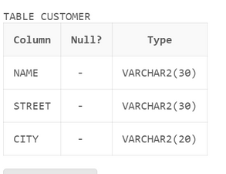

1. Insert records into the table.

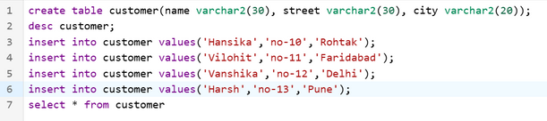

Output:

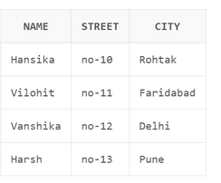

1. Alter the table column domain.

94c3b56ab14804ffd51a3bd7924d0632.png

Output:

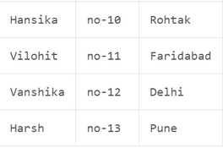

1. Add salary column to the table.

14f8a6a53cb9312a18b48727cf98bf09.png

Output:

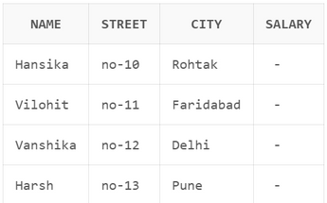

1. Drop salary column of the customer table.

4f9213e6f1da86224fdd752e41b82880.png

Output:

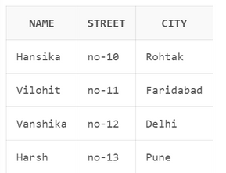

1. Delete the rows of customer table whose cust_city is ‘hyd’.

a18aa73d1a0a267fee480e59aab86a78.png

Output:

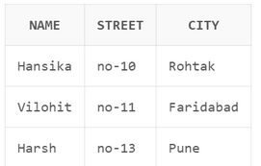

**Exercise No.-4**

**TITLE: CREATION OF TABLES**

**4)** Create table called branch table.

|  |  |
| --- | --- |
| **Name** | **Type** |
| Branch name | Varchar2(20) |
| Branch city | Varchar2(20) |
| Asserts | Number |

**Objective: Implement the basic knowledge of SQL queries and relational algebra.**

**Pre-requisites: Basic understanding of SQL**

**SOLUTION:**

1. Increase the size of data type for asserts to the branch.

3109924c6f3dfd582790fdc0fce144f6.png

1. Add and drop a column to the branch table.

Add:

37f9e2ba14d84aa36eb05e2b9666077e.png

Output:

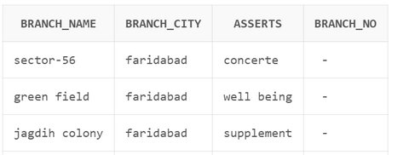

Drop:

d0185fa2b5d8c0995f723d83f936f208.png

Output:

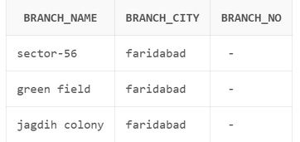

c. Insert values to the table.

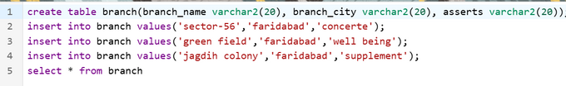

Output:

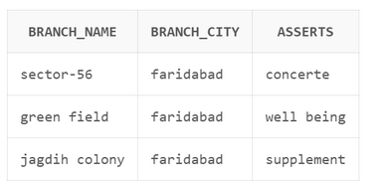

1. Update the branch name column.

9de382b55289186bb429c349d2079a23.png

Output:

dcbf3a27410f9908a7b226b6ffabfb39.png

1. Delete any columns from the table.

b02bf872d2b4cb039e8589fb11c11d46.png

Output:

7527127aa64e9523b3eba5c06f9ee6fe.png

**Exercise No.-5**

**TITLE: CREATION OF TABLES**

5) Create a table called sailor table.

|  |  |
| --- | --- |
| **Name** | **Type** |
| Sid | Number |
| Sname | varchar2(20) |
| Rating | varchar2(20) |

**Objective: Implement the basic knowledge of SQL queries and relational algebra.**

**Pre-requisites: Basic understanding of SQL**

**SOLUTION:**

For creating table

440385ea79a12b68932706d4a6119c04.png

A . Add column age to the sailor table.

6d7d16da379248303eb2148143f13db0.png

1. Insert values into the sailor table.

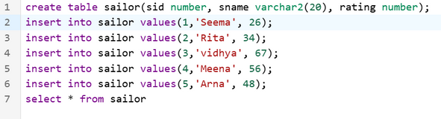

Output:

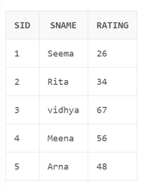

1. Delete the row with rating

9d012ec2543b41a9731a1a44415be28e.png

Output :

e49843f9f774bff00b55719d9256afd0.png

1. Update the column details of sailor.

c5a386e58eb63d41dea054a718dc8234.png

Output :

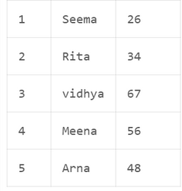

1. Insert null values into the table.

b9d98d3e6961e1e8e3d20f034ffe8d12.png

Output :

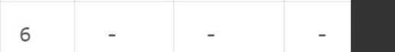

**Exercise No.-6**

**TITLE: CREATION OF TABLES**

6) Create a table called reserves  table.

|  |  |
| --- | --- |
| **Name** | **Type** |
| Boat id | Integer |
| Sid | Integer |
| Day | Integer |

For creation of table :

780458e8ffc4b629796d8ad1bbe8a6ea.png

1. Insert values into the reserves table.

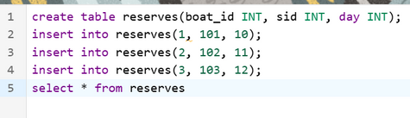

Output :

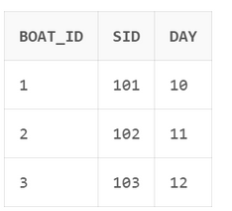

b. Add column time to the reserves table.

36f179e0c08db653bf9a2d6b7a0690b4.png

Output :

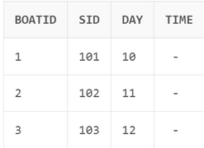

1. Alter the column day data type to date.

c3b30341ddc9453b8fd72e9af5893ced.png

1. Drop the column time in the table.

18e02eacba03ee19a815c7d2260322be.png

Output :

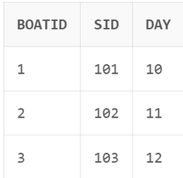

1. Delete the row of the time table with some condition.

b0b21ea11f1c4159497ea75a6b766b2f.png

Output :

